KENNEDY UCHENNA EGUZOZIE

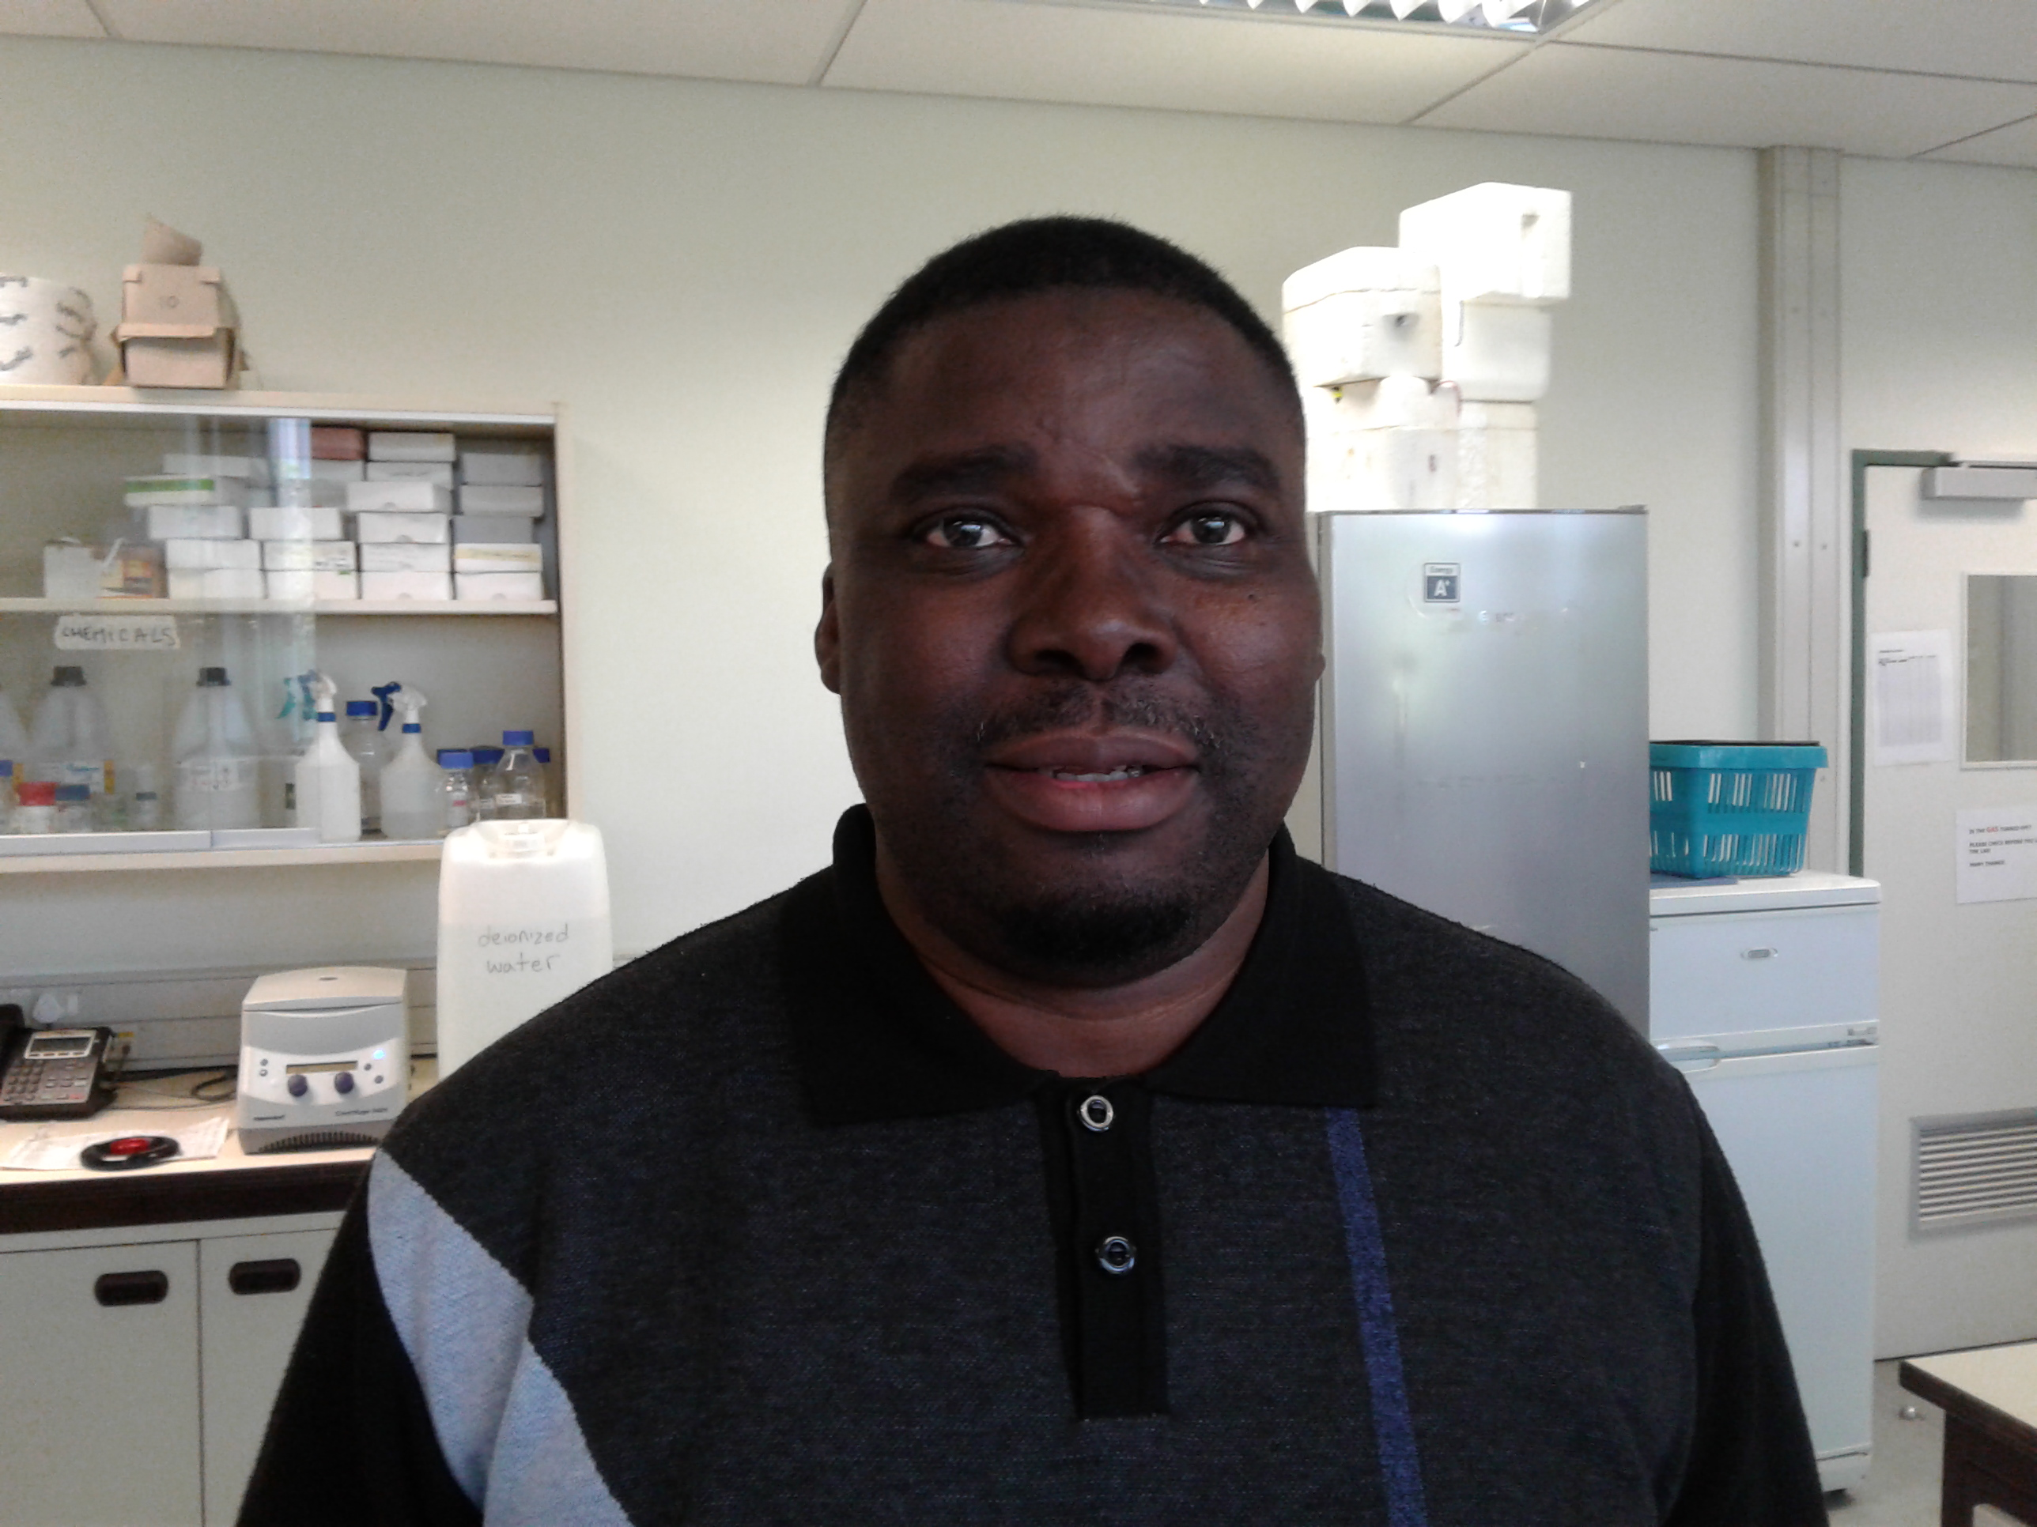

CURRICULUM VITAE

Department of Chemistry/

Forestry and Agricultural Biotechnology Institute

University of Pretoria

Pretoria, South Africa

April 2018

UNIVERSITY OF PRETORIA

1. BIOGRAPHICAL SKETCH

1.1 GENERAL INFORMATION
Surname | Eguzozie
First names | Kennedy |  |  |  |  |  | ID Number |  |  |  | 6912056174089
Citizenship | South African |  |  |  |  |  | Title |  | Dr. |  | Female |  |  |  | Male |  | X
Place of birth | Buea, Cameroon |  |  |  |  |  | Date of birth |  |  |  | 1969-12-05
Population group | African | X | Coloured |  | Indian |  |  | White |  |  | Other  (Please specify)
Department | Chemistry/FABI |  |  |  |  |  | Position |  |  |  | Postdoctoral Fellow
Direct Telephone | 0638270297/0763173476 |  |  |  |  |  | Direct Telefax
E-mail | kennedy.eguzozie@fabi.up.ac.za/eguzoziekennedy@yahoo.co.uk
Date of appointment |  |  |  |  |  | Permanent full-time |  |  |  |  |  |  | Temporary full-time |  |  | X

1.2 ACADEMIC QUALIFICATIONS OBTAINED
Degree | Field of study | Higher education institution | Year | Distinctions
BSc Hons | Chemistry | University of Ibadan, Nigeria | 1994
MSc | Chemistry | University of South Africa | 2008
PhD | Chemistry | University of South Africa | 2012

1.3 WORK EXPERIENCE TO DATE
Name of employer | Capacity and/or type of work | Period  From (mm//yy to mm//yy)
University of Pretoria | Post-doctoral | 04-2018 to present
University of Johannesburg | Post-doctoral | 05-2014 to 12-2017
University of South Africa | Chemistry Lecturer | 05-2012 to 04-2014
University of South Africa | Postgraduate Assistant (PhD) | 02-2009 to 03-2012
University of South Africa | Postgraduate Assistant (MSc) | 05-2006 to 12-2008
International Institute for Tropical Agriculture (IITA), Ibadan, Nigeria | Laboratory Assistant | 11-1995 to 08-1997

2. TEACHING ACTIVITIES

2.1 Courses presented
Course | Level (e.g. second year, Masters) | Self developed  (Yes or No)
Inorganic Chemistry (CHE 4601) | BSc Hons | Partially
Inorganic Chemistry (CHE 3601) | BSc third year | Partially
Introduction to Materials Science and Engineering (MSE 301) | BSc third year | Partially
Inorganic Chemistry, (CHE 2611) | BSc second year | YES
Science Engineering Access (SCIENT-P) | BSc first year | YES
General Chemistry (CHE 1503) | BSc first year | YES
Scientific writing | BSc Hons and postgraduate groups in general | Yes
Guest lectures in courses in Bio-Inorganic Chemistry, Environmental Chemistry | BSc and BSc Hons | Yes
Student-supervisor relationship, time management, life-long learning and other topics related to postgraduate studies | MSc and BSc Hons | Yes

3. POSTGRADUATE SUPERVISION

Name of student | Degree/Title of dissertation/ thesis | Supervisor | Co-supervisor(s)
Irene Mailula | MSc / Occurrence, Detection and Identification of Microcystins in a South African freshwater reservoir employing liquid chromatography electrospray ionization mass spectrometry techniques. | Eugenie Kayitesi | Vuyo Mavumengwana  Kennedy Eguzozie
Cindy Sephokoane | MSc / LC-ESI-MS analytical techniques for the determination of cyanotoxins in a water environment. | Eugenie Kayitesi | Vuyo Mavumengwana  Kennedy Eguzozie
Nkem Uche-Okereafor | MSc / Optimized solid phase microextraction followed by liquid chromatography electrospray ionization mass spectrometry techniques for the characterization of Microcystins in an aquatic environment. | Eugenie Kayitesi | Kennedy Eguzozie
Kagaugelo Cornelius Tapala | BSc Hons / Determination of free phosphates in MealiMeal and Groundnuts by UV-Visible and Vibrational Spectroscopy. | Fikru Tafesse | Kennedy Eguzozie  Martin Enemchukwu
Jubery Mosima Monareng | BSc Hons / Quantitative and qualitative analysis of soluble phosphates in carbonated and caffeinated sugar and sugar free beverages. | Fikru Tafesse | Kennedy Eguzozie  Martin Enemchukwu
Mark Smith | BSc Hons/ Application of Surface Enhanced Raman Scattering (SERS) techniques in the determination of toxic aryl organophosphate esters in fresh water. | Fikru Tafesse | Kennedy Eguzozie  Martin Enemchukwu

3. RESEARCH FUNDING

3.1 Obtaining research funds
Origin of research funds | Title of research project or program | Duration
NRF/RISA Innovation Postdoctoral Fellowship. | Molecular Phylogeny and Chemical Analytical Approach for Identification and Detection of Harmful Algal Bloom Species (dinoflagellates) and its Biotoxins in Water | 2015 - 2017
South African Sugarcane Institute | Chemical ecology of sugarcane insect pest | 2018-present

4. RESEARCH OUTPUTS

4.1 Publications in peer-reviewed or refereed journals
(13) Kennedy Eguzozie, Vuyo Mavumengwana, Duduzile Nkosi, Eugenie Kayitesi, (2018) “Toxigenic K. mikimotoi dinoflagellate species from Phakalane pond: PCR amplification of PbTx-1 and PbTx-2 genes, C18 SPEC microextraction followed by LC-ESE-MS detection and identification of associated produced algal brevetoxins”. Earth Science Research (Accepted).
(12) Kennedy Eguzozie, Vuyo Mavumengwana, Duduzile Nkosi, Eugenie Kayitesi, Emmanuella C. Nnabuo-Eguzozie (2017) Prevalence and Quantitative Variations of Toxic Monocyclic Heptapeptides “Microcystins” in the Phakalane Freshwater Pond, Gaborone, Botswana. Earth Science Research (Accepted).
(11) Kennedy Eguzozie, Vuyo Mavumengwana, Duduzile Nkosi, Eugenie Kayitesi, (2017) “Intracellular low-immunogenic peptide hepatotoxin microcystin. An increasing risk to health and ecosystem by harmful cyanobacterial hyperbloom in a Sub Saharan drinking freshwater reservoir”. Inland Waters (Under review).
(10) Kennedy Eguzozie, Vuyo Mavumengwana, Duduzile Nkosi, Eugenie Kayitesi, Emmanuella C. Nnabuo-Eguzozie (2016) Screening of Cyanobacterial Peptide Toxin, Microcystins in Hyperscum Water Samples from an Inland Sub Saharan Drinking Freshwater Reservoir. Bulletin of Environmental Contamination and Toxicology DOI: 10.1007/s00128-016-1916-2.
(9) Kennedy Eguzozie, Vuyo Mavumengwana, Duduzile Nkosi, Eugenie Kayitesi, Emmanuella C. Nnabuo-Eguzozie (2016) Bioaccumulation and Quantitative Variations of Microcystins in the Swartspruit River, South Africa (2016) Archives of Environmental Contamination and Toxicology DOI: 10.1007/s00244-016-0269-5.
(8) Kennedy Eguzozie, Vuyo Mavumengwana, Duduzile Nkosi, Eugenie Kayitesi, Emmanuella C. Nnabuo-Eguzozie (2016) Incidence of Microcystins (Hepatotoxins) in floating scums in the Swartspruit River, South Africa. Applied Ecology and Environmental Research DOI: http://dx.doi.org/10.15666/aeer/…..
(7) Kennedy Eguzozie, Fikru Tafesse (2013) Monitoring Phosphorylation and Dephosphorylation Reactions by Surface Enhanced Raman Scattering (SERS) in Model Compounds. Phosphorus, Sulfur and Silicon and the Related Elements 188: 1555-1563.
(6) Kennedy Eguzozie (2012) Absorption Spectroscopy and Surface Enhanced Vibrational Techniques for Monitoring Dephosphorylation and Phosphorylation Reactions in Model Compounds (PhD Thesis).
(5) Kennedy Eguzozie, Fikru Tafesse (2011) Mechanistic Aspects of Pyrophophorylation Reactions from Model Studies. Synthesis and Reactivity in Inorganic, Metal-Organic and Nano-Metal Chemistry 41: 1005-1013.
(4) Kennedy Eguzozie, Fikru Tafesse (2010) An Insight into Phosphorylase Mechanism from Model Studies. Synthesis and Reactivity in Inorganic, Metal-Organic and Nano-Metal Chemistry 40: 826-830.
(3) Kennedy Eguzozie, Fikru Tafesse (2009) “Efficient hydrolysis of nitrophenylphosphate catalysed by copper dipyridyl in microemulsions: A model for decontamination of aryl organphosphates in the environment”. Journal of Ecotoxicology and Environmental Safety, 72, 954-959.Environmental Safety 72: 954-959.
(2) Kennedy Eguzozie, Fikru Tafesse (2008) Chemical decontamination studies of phosphate esters in aqueous and microemulsion media promoted by cobalt-amine model systems. Synthesis and Reactivity in Inorganic, Metal-Organic and Nano-Metal Chemistry, 38: 484-490.
(1) Kennedy Eguzozie (2008) Metal Ion Mediated Hydrolysis of 4-Nitrophenylphosphate in Microemulsion Media: Catalytic versus Stoichiometric Effects (MSc Dissertation).

5. OTHER SCHOLARLY RESEARCH-BASED CONTRIBUTIONS

5.1 Participation in conferences, workshops and short courses

5.1.1 National
Invited - Kennedy Eguzozie “Cysteine terminus-molecularly imprinted nano-polymers for selective recognition and identification of hepatotoxic microcystins in a potable freshwater impoundment”. International Conference on Advances in Natural Resources (ICASETNR 16), Parys, South Africa, 24-25, November, 2016.
Invited - Kennedy Eguzozie “Incidence of Microcystins (Hepatotoxins) in floating scums in the Swartspruit River, South Africa”, CSIR, 3rd October, 2016.
Invited - Kennedy Eguzozie “Determination of brevetoxins (PbTx-2 & PbTx-3) from scum samples of toxigenic k. mikimotoi species isolated from an Inland Estuary”, Innovation and Research Symposia, Magalesburg Resort, 8th August, 2016.
Invited - Kennedy Eguzozie “Monitoring and health hazard implications associated with occurrence and quantitative variations of hepatotoxins microcystins in cultures of microcystis flos-aquae (cyanobacteria) isolated from hyperbloom water samples collected from a portable drinking freshwater pond”, Chemistry Departmental Seminar, University of South Africa, 22nd April, 2015
Invited - Kennedy Eguzozie “Monitoring Phosphorylation and Dephosphorylation Reactions by Surface Enhanced Raman Scattering (SERS) in Model Compounds”, Departmental Seminar, Tshwane University of Technology, 9th, December, 2014.
Invited - Kennedy Eguzozie “Catalytic dephosphorylation of nitrophenylphosphate by copper dipyridyl complexes in amphoteric and anionic microemulsion media: South African Chemical Institute International Conference, University of Witwatersrand, Johannesburg, South Africa. 9th June 2009.
Invited - Kennedy Eguzozie “Dephosphorylation of nitrophenylphosphate catalyzed by copper dipyridyl complexes in cationic microemulsion media: South African Chemical Institute International Conference, University of Stellenbosch, Cape Town, South Africa” 6th December 2008.
5.1.2 International
Invited - Kennedy Eguzozie “Prevalence of Toxic Monocyclic Heptapeptides “Microcystins” from Bloom Cultures of Microcystis flos aquae in a Freshwater Pond”. Eurotox 2016 – 52nd Congress of European Societies of Toxicologies. Seville, Spain, 4-7 September, 2016.
Invited - Kennedy Eguzozie “Prevalence of Toxic Monocyclic Heptapeptides “Microcystins” from Bloom Cultures of Microcystis flos aquae in a Freshwater Pond”. 7th Euro-Global Summit on Toxicology and Applied Pharmacology, Rome, Italy, 24-26, October, 2016.
Invited - Kennedy Eguzozie “Application of cysteine terminus-molecularly imprinted nano-polymers for selective recognition and identification of hepatotoxic microcystins in a freshwater reservoir”. ISEAC 39 – International Conference Series on Environmental & Food Monitoring, Hamburg, Germany, 19-22, July, 2016.
Invited - Kennedy Eguzozie “Incidence of microcystin (hepatotoxin) in floating scum in the Swartspruit River, South Africa”. 8th International Conference on Marine Pollution and Ecotoxicology, Hong Kong, 20-24, June, 2016.
Invited - Kennedy Eguzozie "8th International Conference of the Environmental Effects of Nanoparticles and Nanomaterial, Aix Marseille University, France”, 8-12, June, 2014.
Invited - Kennedy Eguzozie "IV International Conference on Colloid Chemistry & Physicochemical Mechanics (IC-CCPCM), Moscow, Russia”. June 30-05 July 2013.

5.2 Membership in national and international bodies
Member: American Chemical Society (Membership No: 30609250)
Member: South African Chemical Institute (Membership No: 16689)
Member: Water Institute of Southern Africa (Membership No: 23480)
Member: Chemometric Society of South Africa (Membership No: 14326)
Member: Chemical Society of Nigeria (University of Ibadan Chapter)

6. ADMINISTRATIVE DUTIES
6.1 Departmental administrative duties
Departmental Representative to the Science Foundation Program, University of South Africa (2008-2012).
Postgraduate student representative, Department of Chemistry, University of South Africa (2009-2011).

7. COMMUNITY SERVICE OR PROFESSIONAL SKILLS

7.1 Outreach projects
Pioneering member, demonstrator and motivational speaker at the MathsEdge Community Development Project of the College of Science, Engineering & Technology, University of South Africa (2011 & 2013).
Pioneering member, Learner Research Summit which is also another community engagement project of the College of Science, Engineering and Technology in the University of South Africa (2011 & 2012).
Demonstrator and motivational speaker at GirlPower Carrier Exhibition Community Development Project of the College of Science, Engineering & Technology of the University of South Africa in 2011 & 2012.
Technical judge at LEGO League Flagship Community Development Project of the College of Science, Engineering & Technology of the University of South Africa (2009 & 2010).

8. AWARDS AND SCIENTIFIC/SCHOLARLY RECOGNITION

8.1 NRF Reviewer and Evaluator
Reviewer and evaluator for the National Research Foundation where I was invited to assist in appraising the application submitted by Prof H I Atagana titled “Application of Nanoscience and Nanotechnology in Biological Treatment of Mine Wastewater”.
DAAD-NRF Masters and Doctoral Scholarships (Natural, Earth and Environmental Sciences) 24 - 26 November 2015

8.2 Research awards and prizes
NRF/RISA 2015 Innovation Postdoctoral Fellowship (2015 – 2017).
Post Graduate Merit Award of the University of South Africa (2007-2012).
Prof M.J Mphahlele NRF Grant Holder Bursary Award for outstanding Post Graduate Student (2009-2012).
Ecotoxicology Research Flagship Award (MSc & PhD) of the University of South Africa (2008-2012).
Prof M.J Mphahlele NRF Grant Holder Bursary Award for outstanding Post Graduate Student (MSc) 2007-2008.
GROW YOUR OWN TIMBER SCHOLARSHIP PROGRAM AWARD (MSc & PhD) of the College of Science Engineering and Technology of the University of South Africa 2006-2012.
South African Chemical Institute (SACI) Young Spectroscopist Symposium award for 2nd best MSc oral presentation (2007).

Indicate whether Honours, Masters research, Masters coursework with dissertation or Doctorate

